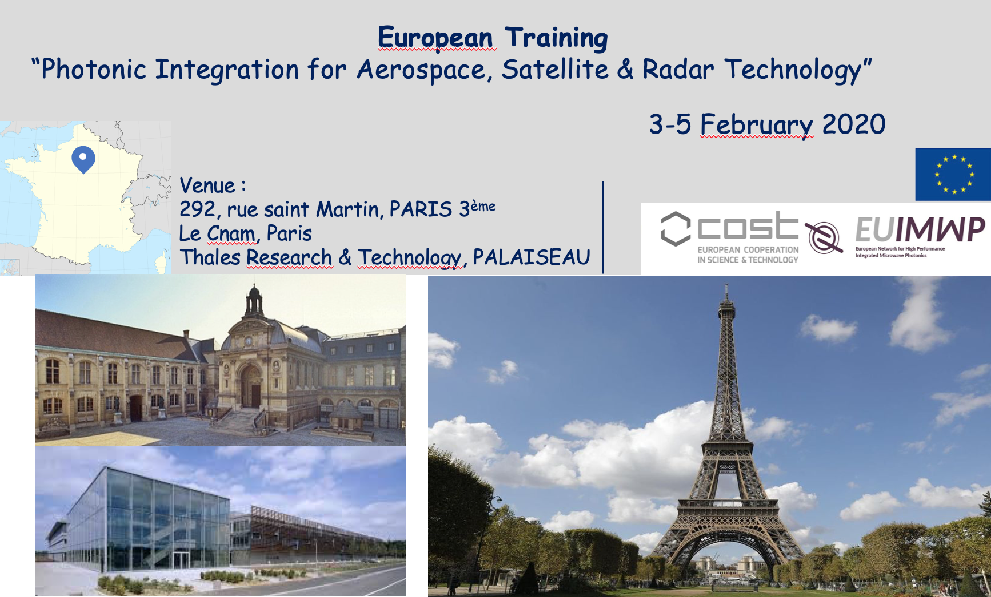
Training School
Photonic Integration for Aerospace, Satellite & Radar Technology
3rd – 5th of February 2020, Paris & Palaiseau

Dear EUIMWP participants,
On behalf of the MC of the EUIMWP (CA 16220) COST Action, we are pleased to announce a Training School on “Photonic Integration for Aerospace, Satellite & Radar Technology”, to be held in Paris, 3rd to 5th of February 2020.
Organized by Le Conservatoire National des Arts et Métiers (Le Cnam) and Thales Research and Technology (TRT) within the framework of the EUIMWP Cost Action (European Integrated Microwave Photonics), this training school covers the application of integrated photonics for aerospace, satellite & radar technology.

1 - Space
- Free space optical communications
- Spatial environment, Cost-effective and low-SWaP telecommunications satellite payloads
- A MWP-based Space Instrument
- Highly flexible and reconfigurable photonically-enabled satellite payloads
2 – Radar
- Compact high-frequency beam-steered systems based on IMWP technologies, radar systems of wider spectral bandwidth (>40 GHz), lower timing jitter (<15 fs), and real time signal processing based on photonically-enabled radar implementation through IMWP technologies.
- Integrated Microwave Photonic Filters
The training school will be hosted at the facilities of CNAM in central Paris (for two days: 3-4 Feb.) and at TRT (for one day: 5 Feb.). The training school will include talks from experts based in industry and academia and is mainly intended for Ph.D. students and early career investigators. Two visits to industrial laboratories will be organized.

Registration
Attendance at the Training School is free of charge, but requires registration.
Please fill in the attached document and send it to:

anne-laure.billabert@lecnam.net

Deadline: December 15th, 2019

Location:

3-4 February:
Le Cnam, Salon d’honneur,
292, rue saint Martin, 75003 Paris

5 february:
Thales Research & Technology
Route départementale, 91120 Palaiseau

Organizing committee
Dr. Anne-Laure Billabert (anne-laure.billabert@lecnam.net)
Dr. Daniel Dolfi (daniel.dolfi@thalesgroup.com)
Prof. Stavros Iezekiel (iezekiel@ucy.ac.cy)

Grants for attending the Training School:
The EUIMWP (CA 16220) COST Action will offer a fixed grant (amount still to be confirmed) to trainees coming from COST countries and Near Neighbour Countries (please check the eligibility conditions in the COST Vademecum, downloadable from the right menu of the COST website (https://www.cost.eu/funding/how-to-get-funding/documents-and-guidelines/). These grants are a contribution to travel, accommodation and meals expenses of trainees during their attendance at the course, but they will not necessarily cover all expenses. The grants will be given on a first come, first served basis, after checking that the eligibility criteria are met. The Grant Holder reserves the right to modify the number of grants according to budget availability. The grants will always be paid a posteriori, after checking that the grantee has attended the entire event and signed the attendance list every day.

How to apply for a grant from the EUIMWP COST Action?
Please send an email to Pepa Bayarri, the Grant Holder Manager of the EUIMWP COST Action (ghmanager.upv@gmail.com) expressing your interest in obtaining a grant, with the following documents attached:
- Document of your acceptance for the training school, signed by the organisers (a copy of their acceptation email will suffice).
- Any kind of proof to show your affiliation to your institution (a letter signed by your supervisor, a copy of your contract/scholarship, etc.).

Should you have any question regarding the COST grants, please contact Pepa Bayarri.
José Capmany (Chair and Grant Holder)
Anne-Laure Billabert (Local Organiser)
Pepa Bayarri (Grant Holder Manager), email: ghmanager.upv@gmail.com

AGENDA
Photonic Integration for Aerospace, Satellite & Radar Technology
3rd – 5th of February 2020, Paris & Palaiseau

- 1st Day – 3rd february 2020 at Cnam - Salon d’honneur,
292 rue St-Martin, 75003 Paris

Time | Speaker | Title | Affiliation
09:30-10:00 |  | Welcome and coffee break
10:00-10:10  10:10-11:10  11:10-12:10 | Prof.Catherine Algani  Dr.Frédéric Van Dijk  Prof.Philippe Di Bin | Welcome at Cnam  Indium Phosphide and silicon nitride photonic integrated circuits for LIDAR and microwave photonic applications  Microwave photonics signal processing for frequency management and beamforming applications | ESYCOM/ Le Cnam  III-V Lab  XLIM
12:10-14:00 | Lunch Break
14:00-15:00  15:00-16:00 | Dr.Chris Roeloffzen  Dr.Jérome Bourderionnet |  | LioniX  Thales Research & Technology
16:00-16:15 | Coffee Break
16:15-17:15 | Dr.Colm Browning | “Photonic Techniques for High Frequency Carrier Generation and Data Communications” | Dublin City University

- 2nd Day – 4th February 2020 at Cnam - Salon d’honneur,
292 rue St-Martin, 75003 Paris

Time | Speaker | Tentative Title | Affiliation
09:30-10:30  10:30-11:30 | Dr. François Deborgies  Dr. Michel Sotom | SMOS : A MWP-based Space Instrument | ESA  Thales Alenia Space
11:30-11:45 | Coffee Break
11:45-12:45 | Prof.Angélique Rissons |  | ISAE
12:45-14:00 | Lunch Break
14:00-15:00  15:00-16:00 | Prof. Tobias Kippenberg  Prof. Stavros Iezekiel | “Optoelectronic oscillators and optical combs for aerospace applications” | EPFL  University of Cyprus
 | Visit of Cnam museum

- 3rd Day – 5th February 2020 at Thales Research & Technology

Time | Speaker | Tentative Title | Affiliation
09:30-10:30  10:30-11:30 | Dr. Alfredo De Rossi  Dr.Jean-Luc Polleux | Nanoscale Photonic Technologies for energy-efficient all-optical signal processing  Low cost and high performances approaches for Optical interconnects and Radio-over-Fiber with applications in beamforming, radar and aerospace applications | Thales Research & Technology  ESYCOM/ESIEE Paris
11:30-11:45 | Coffee Break
11:45-12:45 | Dr. Benoit Charbonnier | Silicon photonics for communication and emerging applications | CEA Leti
12:45-14:00 | Lunch Break
14:00-15:00 | Dr. David Marpaung | Integrated Microwave photonic filters | University of Twente
15:00-16:30 | Visit of labs : TRT and III-V lab

